Index

1. Research 2

2. Feasibility Studies 4

2.1. Technical Feasibility: 4

2.2. Economic Feasibility 4

2.3. Operational Feasibility: 5

3. System Requirement specification 7

3.1. Introduction to SRS 7

3.2. Abstract 7

3.3. System Users 7

3.4. Modules 8

3.5. Modules Description 8

3.6. Hardware required 9

3.7. Time Line Chart 10

4. Technology description 11

4.1. Limitations and features 12

5. Data Flow Diagram 13

5.1. Context Level DFD’s: - 13

5.2. Level 1 DFD’s: - 14

5.3. Level 2 DFD’s: - 18

5.4. Level 3 DFD’s: - 19

6. Activity Diagram 20

6.1. Description of activity Diagram 20

7. E-R Diagram 23

7.1. E-R Diagram Description 23

8. Data dictionary 24

8.1. Description of data dictionary 24

9. Form Design (Screenshots) 27

# Research

Research may be very broadly defined as systematic gathering of data and information and its analysis for advancement of knowledge in any subject. research attempts to find answer intellectual and practical questions through application of systematic methods.

Types of research can be classified in many different ways. some major ways of classifying research include the following.

* Descriptive Research
* Applied Research
* Quantitative Research
* Conceptual Research

Descriptive research concentrates on finding facts to ascertain the nature of something as it exists. In contrast analytical research is concerned with determining validity of hypothesis based on analysis of facts collected.

Applied research is carried out to find answers to practical problems to be solved and as an aid in decision making in different areas including product design, process design and policy making. Fundamental research is carried out as more to satisfy intellectual curiosity, than with the intention of using the research findings for any immediate practical application.

Quantitative research studies such aspects of the research subject which are not quantifiable, and hence not subject to measurement and quantitative analysis. In contrast quantitative research makes substantial use of measurements and quantitative analysis techniques.

Conceptual research is involving investigation of thoughts and ideas and developing new ideas or interpreting the old ones based on logical reasoning. In contrast empirical research is based on firm verifiable data collected by either observation of facts under natural condition or obtained through experimentation.

**It’s Benefit**

* Better understand evolving community needs
* Inform program development and refinement
* We can find which type of new things need.
* Measure the outcomes of programs and account for use of resources
* Create new understanding about what works and what does not
* Strengthen the case for program funding

# Feasibility Studies

Feasibility studies aim to objectively and rationally uncover the strengths and Weaknesses of the existing system or proposed venture. In its simplest term, the two criteria to judge feasibility are cost required and value to be attained. As such, a well-designed feasibility study should provide historical background of the project. Generally, feasibility studies precede technical development and Project implementation.

The assessment of feasibility study is based on the following factors:

## Technical Feasibility:

Generally, feasibility studies precede technical development and project implementation. The assessment is based on a system requirement in terms of Input, Processes, Output, Fields, Programs, andProcedure. This can be quantified in terms of volumes of data, trends, frequency of updating, etc., in order to estimate whether the new system will perform adequately or not. Technological feasibility is carried out to determine the capability, in terms of software, hardware, personnel and expertise, to handle the completion of the project. When writing a feasibility report the following should be taken to consideration:

* A brief description of the business
* The part of the business being examined
* The human and economic factor
* The possible solutions to the problems

In technical Feasibility we can show which type of Technology we are using to build our system like OS- windows and application is XAMPP server and SQL server.

## Economic Feasibility

Economic analysis is the most frequently used method for evaluating the effectiveness of a new system. More commonly known as cost/benefit analysis, the procedure is to determine the benefits and savings that are expected from a candidate system and compare them with costs. E-playground is cost effective because we can access our system on any operating system through using browser. The only cost of our system is server cost.

## Operational Feasibility:

Operational feasibility is a measure of how well a proposed system solves the problems, and takes advantage of the opportunities identified during scope definition and how it satisfies the requirements identified in the requirements analysis phase of system development the operational feasibility of the system can be checked as it solves the problems and reduces the complications occurring in the paper-pencil test. We have also reduced the paper work here if we find any error then we provide a facility of complain box where we can send their error through admin and other user then can easily solve their error.

**Software Development Life Cycle**

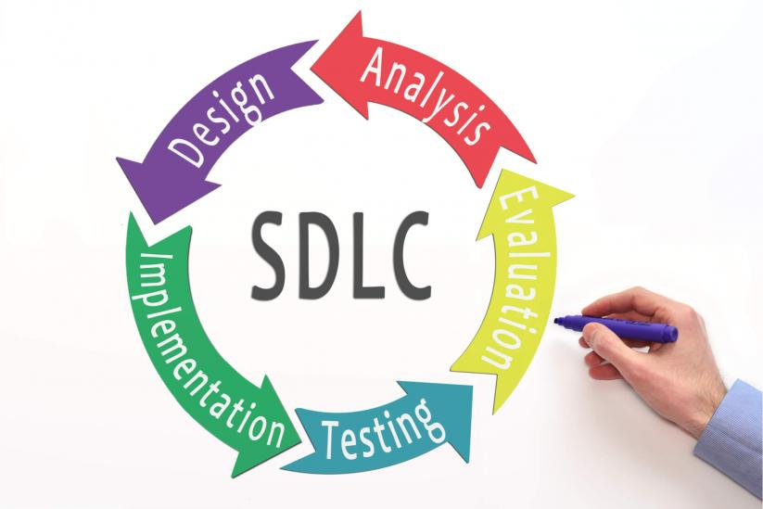

* **System Analysis**

At this step the developers decide a roadmap of their plan and try to bring up the best software model suitable for the project. System analysis includes Understanding of software product limitations, learning system related problems or changes to be done in existing systems beforehand, identifying and addressing the impact of project on organization and personnel etc. The project team analyses the scope of the project and plans the schedule and resources accordingly.

* **Software Design**

Next step is to bring down whole knowledge of requirements and analysis on the desk and design the software product. The inputs from users and information gathered in requirement gathering phase are the inputs of this step. The output of this step comes in the form of two designs; logical design and physical design. Engineers produce meta-data and data dictionaries, logical diagrams, data-flow diagrams and in some cases pseudo codes.

* **Implementation**

This means installing the software on user machines. At times, software needs post-installation configurations at user end. Software is tested for portability and adaptability and integration related issues are solved during implementation.

* **Evolution**

In evolution phase we can check how to increases or growth of our system in environment. Then also they can check it is user-friendly or not.

* **Testing**

An estimate says that 50% of whole software development process should be tested. Errors may ruin the software from critical level to its own removal. Software testing is done while coding by the developers and thorough testing is conducted by testing experts at various levels of code such as module testing, program testing, product testing, in-house testing and testing the product at user’s end. Early discovery of errors and their remedy is the key to reliable software.

# System Requirement specification

## Introduction to SRS

A software requirements specification (**SRS**) is a description of a software system to be developed. It lays out functional and non-functional requirements, and may include a set of use cases that describe user interactions that the software must provide

## Abstract

The present system enrols the players in different types of tournament like Cricket, Chess, Badminton, etc. In this system Service provider adds the tournament which can be viewed by players get registered for the tournament. We do provide playgrounds on rent also if an owner wants to sell playground on rent then he/she can use this system. In this Players can check their report and also check tournament report

## System Users

There are four users in our system:

* Admin
* Service Provider
* Players

Admin:

* The initial step which is handled by the admin module and manage all the users.
* This will Manage all the Tournament.

Service Provider:

* Service provider add and create tournament into the system and also generate tournament report as well as player report. Service provider also provide the facility of Playgrounds on rent also if an owner wants to sell playground on rent.

Players:

* Players does registration in tournament by using payment method and can check their report and tournament report**.**

## Modules

* List of Modules
* Registration
* Tournament
* Games
* Payment
* Report
* Ground
* Contact us

## Modules Description

1. **Registration**

Through registration Module user can registration into the system by fill up the details. By using this modules Player can easily enroll in tournaments. Player can enroll in system by two ways in a Group of Team otherwise as a single player.

1. **Tournament**

In Tournament module manage the whole tournament like player registration, Tournament report manage, Player manage whole do Tournament module.

1. **Games**

It will use to manage whole games in tournament.

1. **Payment**

This module helps in payment gateway. By using this player can easily pay the tournament charges.

1. **Report**

This module is use to make a report of tournament and players reports.

1. **Ground**

This module for Provide Grounds on rent by paying some charges.

1. **Contact Us**

This module is useful to solve any problem like any user’s registration problem and login problem and also enroll in tournament.

## Hardware required

You will need a PC with an Internet connection. A printer is optional.

System configuration:

* Server configuration
  + Pentium IV(dual core processor operating at 2.20 GHz)
  + 2gb ram
  + 3.5GB Free space hard disk
* Client configuration
  + 1GB ram
  + 1.2 GHz processor
  + 100 MB free harddisk

**Software Requirements**

Internet Browser such as Internet Explorer 6.0 and higher or another browser of the same generation is required to access the application

* Server configuration
* SQL server 2008
* Linux Server.
* Client configuration
* Window xp or higher
* Wamp server
* Google chrome(any browser)

## Time Line Chart

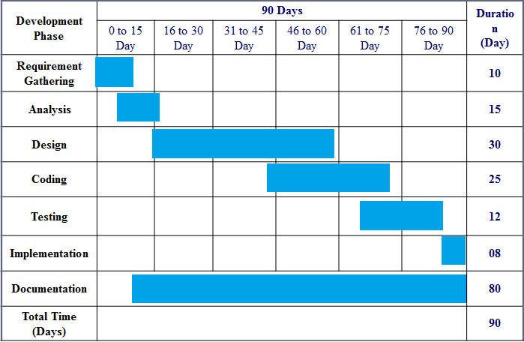

# Technology description

* PHP:
* PHP is an acronym for "PHP: Hypertext Preprocessor"
* PHP is a widely-used, open source scripting language
* PHP scripts are executed on the server
* PHP is free to download and use
* Bootstrap:
* Bootstrap is a free front-end framework for faster and easier web development
* Bootstrap includes HTML and CSS based design templates for typography, forms, buttons, tables, navigation, modals, image carousels and many other, as well as optional JavaScript plugins
* Bootstrap also gives you the ability to easily create responsive designs
* MySQL:
* MySQL is the most popular Open Source Relational SQL Database Management System.
* MySQL is one of the best RDBMS being used for developing various web-based software applications. MySQL is developed, marketed and supported by MySQL AB, which is a Swedish company.
* CSS:
* CSS stands for Cascading Style Sheets
* CSS describes how HTML elements are to be displayed on screen, paper, or in other media
* CSS saves a lot of work. It can control the layout of multiple web pages all at once.
  + J-query:
  + jQuery is a lightweight, "write less, do more", JavaScript library.
  + The purpose of jQuery is to make it much easier to use JavaScript on your website.

## Limitations and features

Limitations:

* Report generation is dificult.
* Xss attack vulnerability
* url redirection
* Mysql Injection

Features:

* Mobile/Tablet/Desktop (Responsive): Our website is totally platform independent that means it can be used with mobile as well as tablet and with desktop.
* The proposed system automates the existing system. It decreases paper work and makes record maintenance easy by having a database for tournament and players records.
* The e-playground system is an internet-based application that can be accessed by any system.

1) Live Player Report.

2) Live Tournament Report.

# Data Flow Diagram

A data flow diagram (DFD) is a graphical representation of the "flow" of data through an information system, modelling its process aspects. A DFD is often used as a preliminary step to create an overview of the system without going into detail, which can later be elaborated. DFDs can also be used for the [visualization](https://en.wikipedia.org/wiki/Data_visualization) of [data processing](https://en.wikipedia.org/wiki/Data_processing) (structured design).

A DFD shows what kind of information will be input to and output from the system, how the data will advance through the system, and where the data will be stored. It does not show information about the timing of process or information about whether processes will operate in sequence or in parallel unlike a [flowchart](https://en.wikipedia.org/wiki/Flowchart) which also shows this information.

## ****Context Level DFD’s: -****

A context level DFD is the most basic form of DFD. It aims to show how the entire system works at a glance. There is only one process in the system and all the data flows either into or out of this process. Context level DFD’s demonstrates the interactions between the process and external entities. They do not contain Data Stores.

When drawing Context Level DFD’s, we must first identify the process, all the external entities and all the data flows. We must also state any assumptions we make about the system. It is advised that we draw the process in the middle of the page. We then draw our external entities in the corners and finally connect our entities to our process with the data flows.

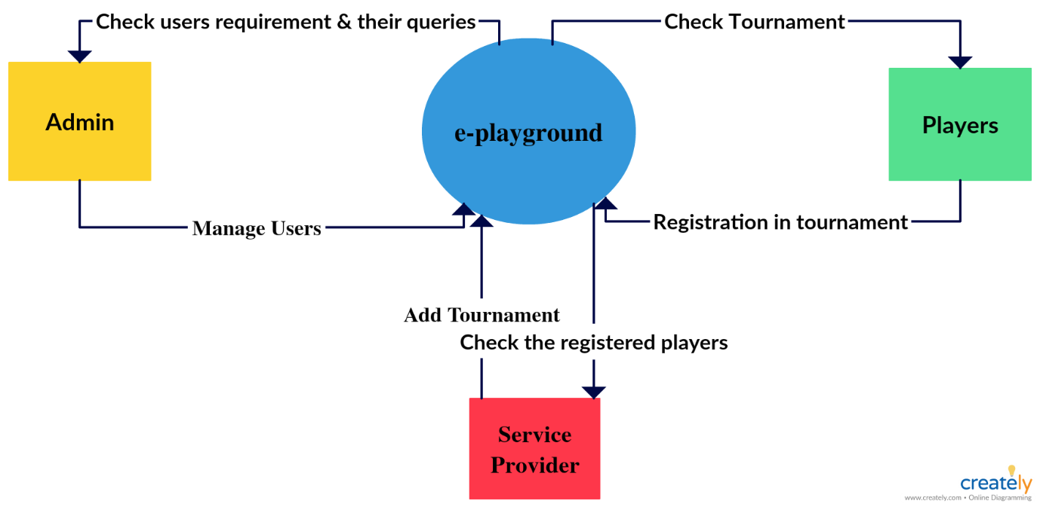

**Fig.** The 0 level DFD show the relation between User and System. It Show them overview of our system how to they are connected to the system.

## ****Level 1 DFD’s: -****

Level 1 DFD’s aim to give an overview of the full system. They look at the system in more detail. Major processes are broken down into sub-processes. Level 1 DFD’s also identifies data stores that are used by the major processes. When constructing a Level 1 DFD, we must start by examining the Context Level DFD. We must break up the single process into its sub-processes. We must then pick out the data stores from the text we are given and include them in our DFD. Like the Context Level DFD’s, all entities, data stores and processes must be labeled. We must also state any assumptions made from the text.

**Level-1 for Admin**

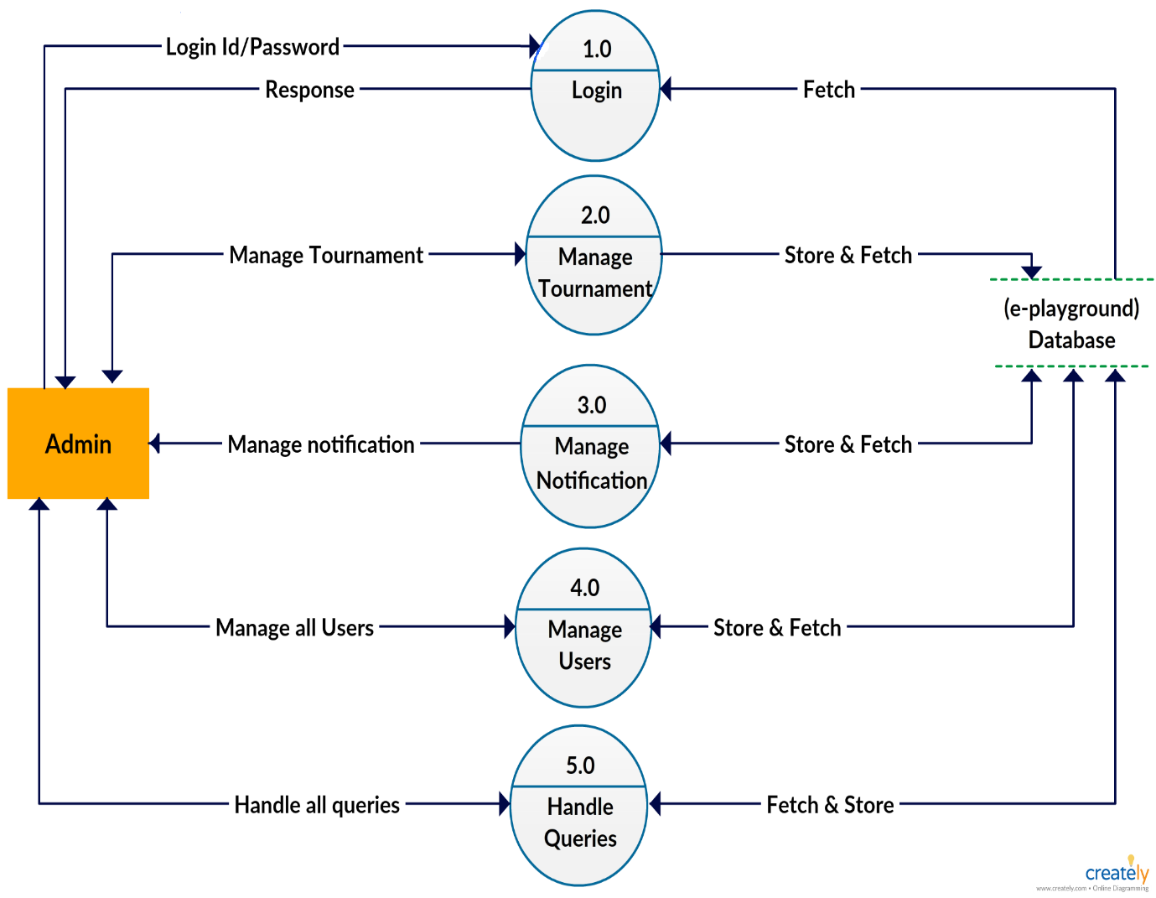

**Fig: -** This DFD show the module available at the Admin and how to they are connected to database and also so which type of works they can do.

**Level-1 for Service Provider**

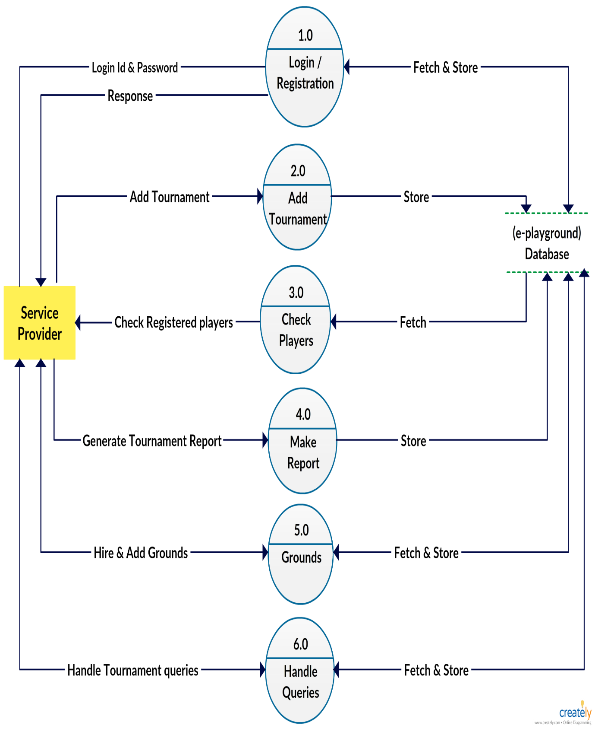

**Fig: -**This DFD show the module available at the Service Provider and how to they are connected to database and also so which type of works they can do.

**Level-1 for Players**

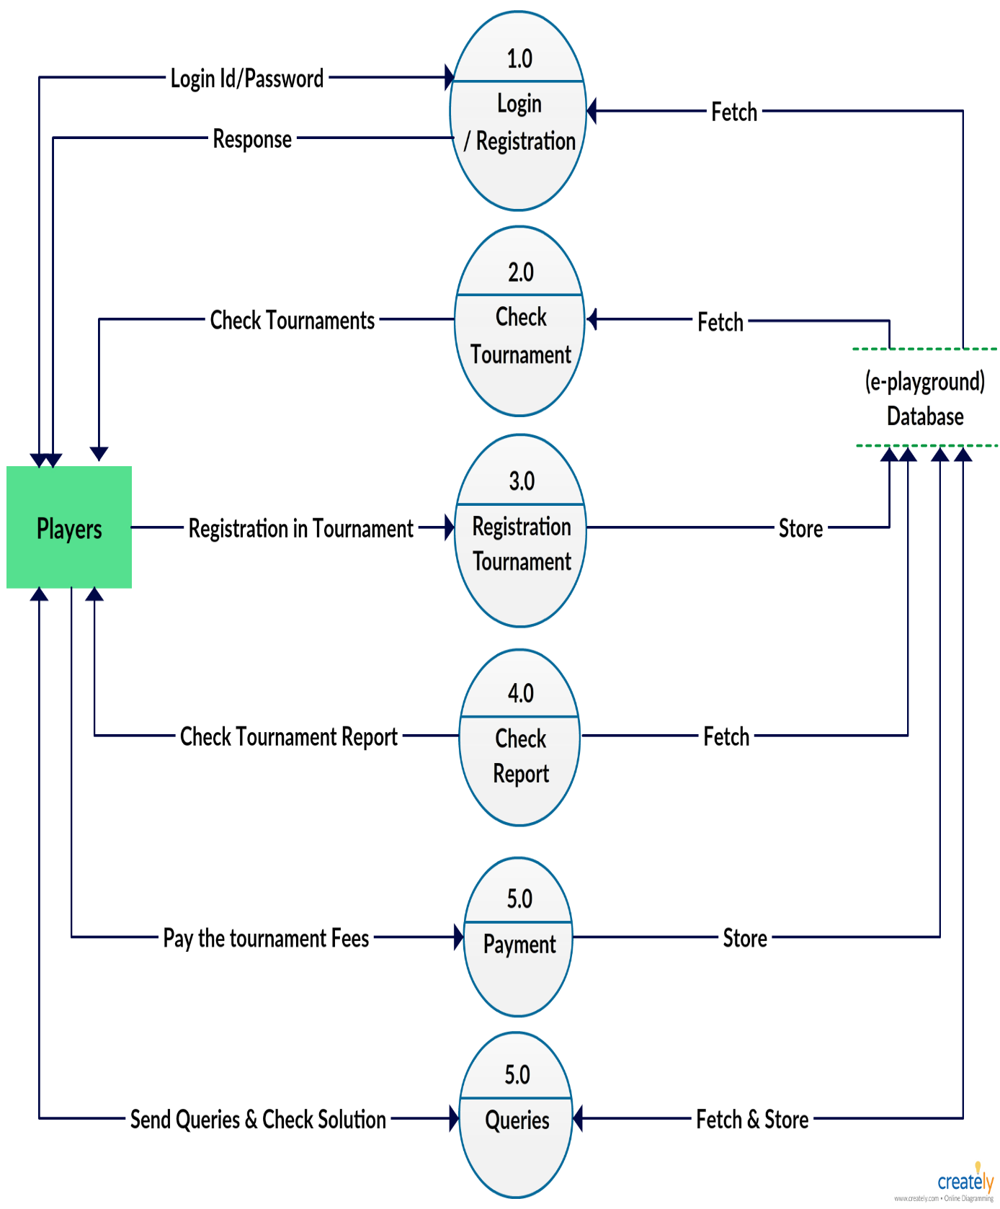

**Fig: -** This DFD show the module available at the Players and how to they are connected to database and also so which type of works they can do.

## ****Level 2 DFD’s: -****

A level 2 data flow diagram (DFD) offers a more detailed look at the processes that make up an information system than a level 1 DFD does. It can be used to plan or record the specific makeup of a system.

**Level-2 for Tournament Registration**

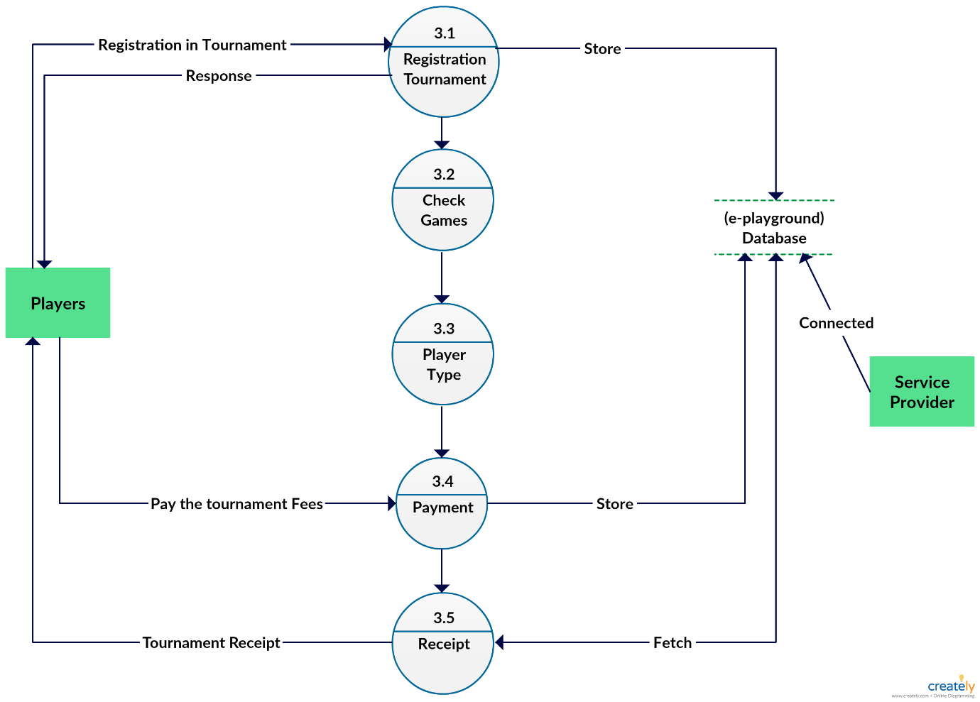

**Fig: -**This DFD show the how Registration Tournament modules are connected to other modules as well as how connected with database

## ****Level 3 DFD’s: -****

A level 3 data flow diagram (DFD) offers a more detailed look at the processes that make up an information system than a level 2 DFD does. It can be used to plan or record the specific makeup of a system.

**Level-1 for Payment Gateway**

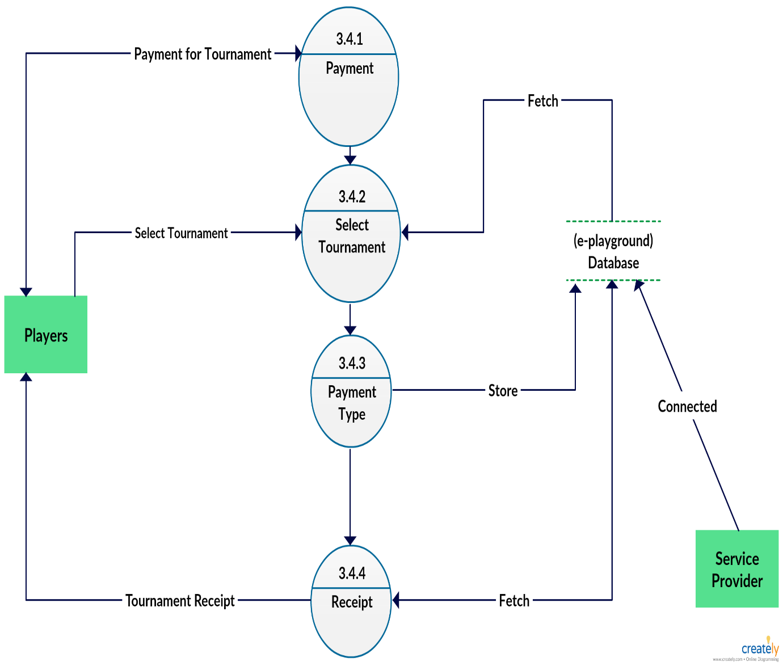

**Fig.** This DFD show the how Payment modules are connected to other modules as well as how connected with database.

# Activity Diagram

## Description of activity Diagram

Activity diagrams are graphical representations of [workflows](https://en.wikipedia.org/wiki/Workflow) of stepwise activities and action switch support for choice, iteration and concurrency. In the [Unified Modeling Language](https://en.wikipedia.org/wiki/Unified_Modeling_Language), activity diagrams are intended to model both computational and organizational processes (i.e. workflows). Activity diagrams show the overall flow of control.

1. **Activity Diagram for Admin**

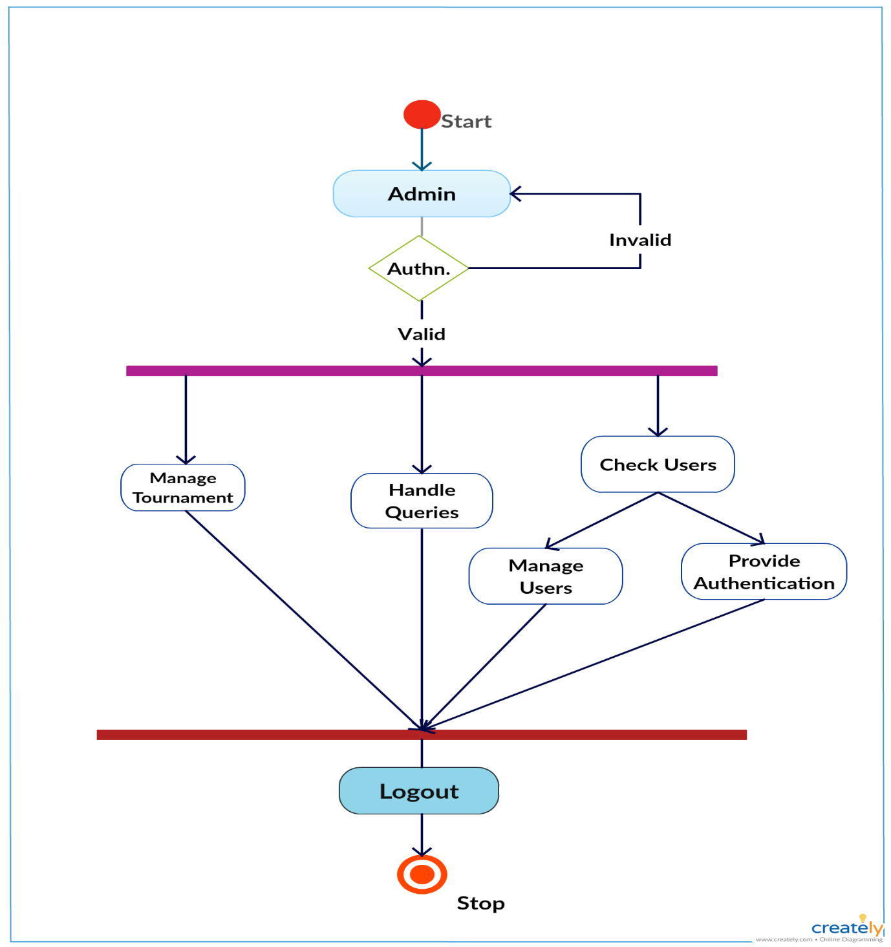

**Fig.** It will show which activity/work will do the Admin in the system.

1. **Activity Diagram for Players**

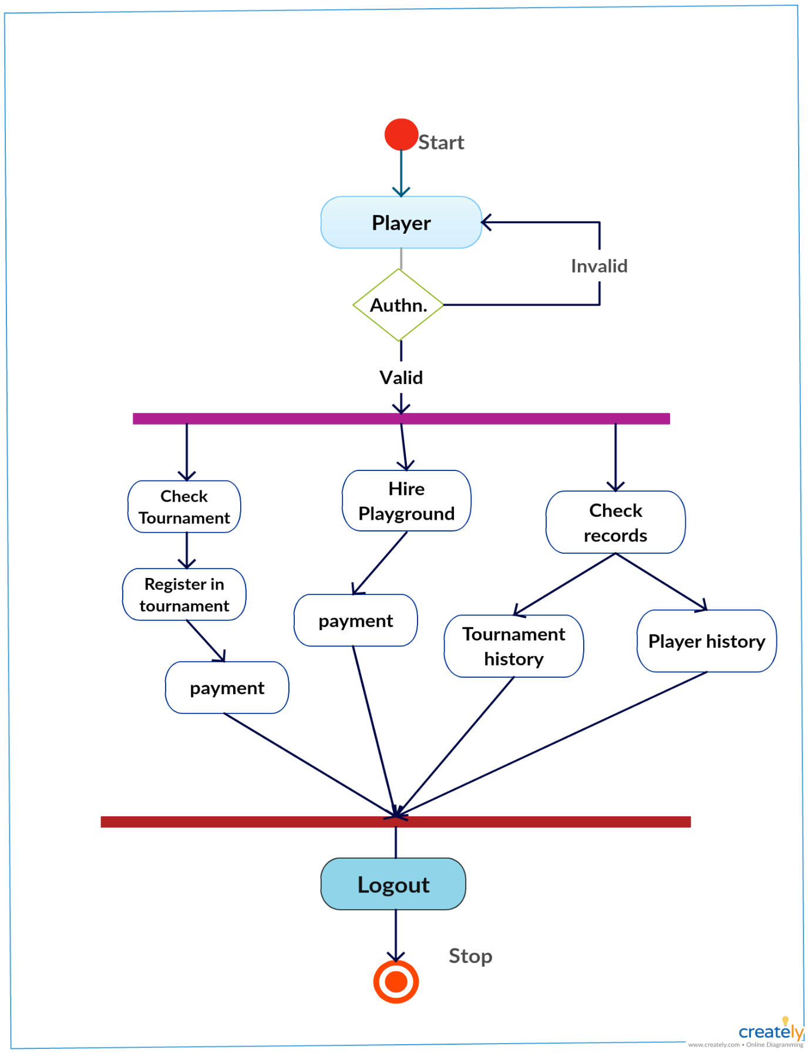

**Fig.** It will show which activity/work will do the Players in the system.

1. **Activity Diagram for Service Provider**

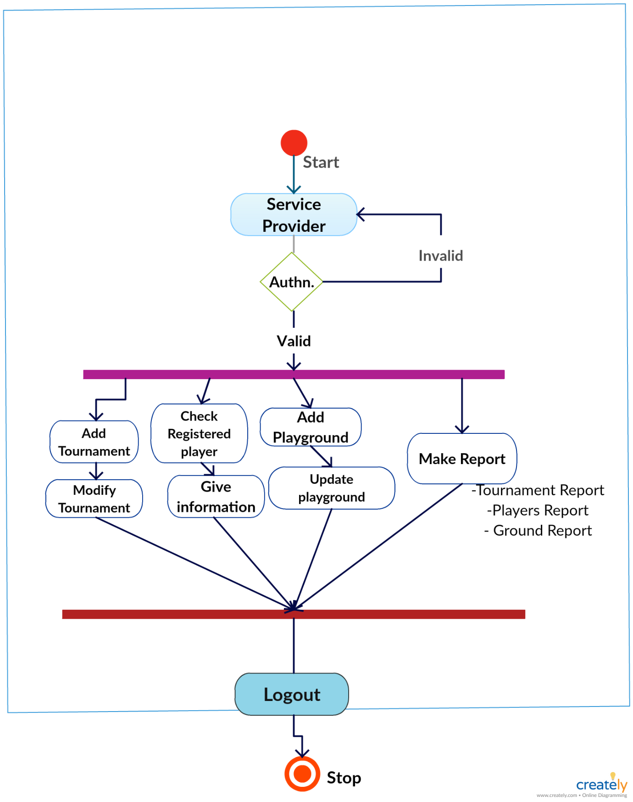

**Fig.** It will show which activity/work will do the Service Provider in the system.

# E-R Diagram

## E-R Diagram Description

An entity relationship model, also called an entity-relationship (ER) diagram, is a graphical representation of entities and their relationships to each other, typically used in computing in regard to the organization of data within [databases](http://www.webopedia.com/TERM/D/database.html) or information systems. An entity is a piece of data-an [object](http://www.webopedia.com/TERM/O/object.html)or concept about which data is stored.

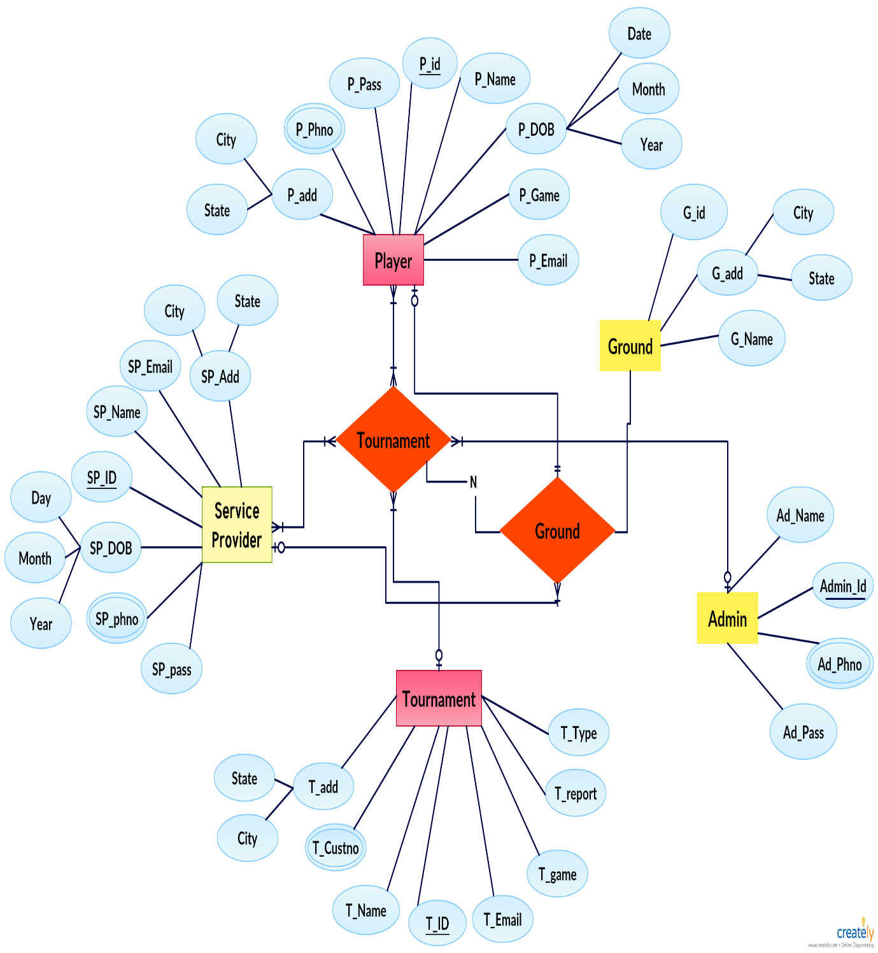

**Fig.**It will show the Relationship of One Entity to another entity Like Admin, Players & Service Provider and also show they attribute.

# Data dictionary

## Description of data dictionary

A data dictionary is a collection of descriptions of the [data](http://searchdatamanagement.techtarget.com/definition/data) objects or items in a data model for the benefit of programmers and others who need to refer to them. A first step in analysing a system of [object](http://searchsoa.techtarget.com/definition/object)s with which users interact is to identify each object and its relationship to other objects. This process is called data modelling and results in a picture of object relationships. After each data object or item is given a descriptive name, its relationship is described (or it becomes part of some structure that implicitly describes relationship), the type of data (such as text or image or binary value) is described, possible predefined values are listed, and a brief textual description is provided. This collection can be organized for reference into a book called a data dictionary.

**Loginmaster**

|  |  |  |  |  |
| --- | --- | --- | --- | --- |
| **Column** | **Type** | **Null** | **Description** | **Example** |
| id (Primary) | int(11) | No | Id | 1 |
| userName | varchar(100) | No | User name | Amit Sinha |
| userId | varchar(100) | No | User id | A123S |
| email | varchar(100) | No | Email id | amit@gmail.com |
| password | varchar(100) | No | User Password | **\*\*\*\*\*\*\*\*** |
| role | enum('A', 'P', 'S') | No | Role of users | Player |

**Tournament master**

|  |  |  |  |  |
| --- | --- | --- | --- | --- |
| **Column** | **Type** | **Null** | **Description** | **Example** |
| id (Primary) | int(11) | No | Id | 1 |
| t_name | varchar(100) | No | Tournament Name | Go Cricket |
| t_register_start | date | No | Registration Start | 20th April 2019 |
| t_register_end | date | No | Registration End | 25th April 2019 |
| t_category | varchar(100) | No | Category | Cricket |
| t_player_type | varchar(100) | No | Player Type | Team |
| t_start | date | No | Tournament Start | 28th April 2019 |
| t_price | varchar(100) | No | Tournament Price | 20000 |
| t_fees | varchar(100) | No | Tournament Fees | 200 |
| t_city | varchar(100) | No | City | Vadodara |
| t_state | varchar(100) | No | State | Gujarat |
| t_venue | varchar(100) | No | Venue | Reliance Stadium |
| status | varchar(100) | No | Status | Active |
| paid | varchar(100) | No | Paid | Paid |

**Service Provider**

|  |  |  |  |  |
| --- | --- | --- | --- | --- |
| **Column** | **Type** | **Null** | **Description** | **Example** |
| id (Primary) | int(11) | No | Id | 1 |
| s_id | int(11) | No | Service Provider id | A123J |
| phone | varchar(11) | No | Phone no | 9998316492 |
| dob | date | No | Date of Birth | 20-12-1996 |
| gender | enum('M', 'F') | No | Gender | Male |
| city | varchar(25) | No | City | Vadodara |
| state | varchar(25) | No | State | Gujarat |
| country | varchar(25) | No | Country | India |

**Player**

|  |  |  |  |  |
| --- | --- | --- | --- | --- |
| **Column** | **Type** | **Null** | **Description** | **Example** |
| id (Primary) | int(11) | No | Id | 1 |
| p_id | int(11) | No | Player id | A123S |
| phone | varchar(11) | No | Phone no | 9998316492 |
| dob | date | No | Date of Birth | 20-12-1996 |
| gender | enum('M', 'F') | No | Gender | Male |
| city | varchar(25) | No | City | Vadodara |
| state | varchar(25) | No | State | Gujarat |
| country | varchar(25) | No | Country | India |

# Form Design (Screenshots)

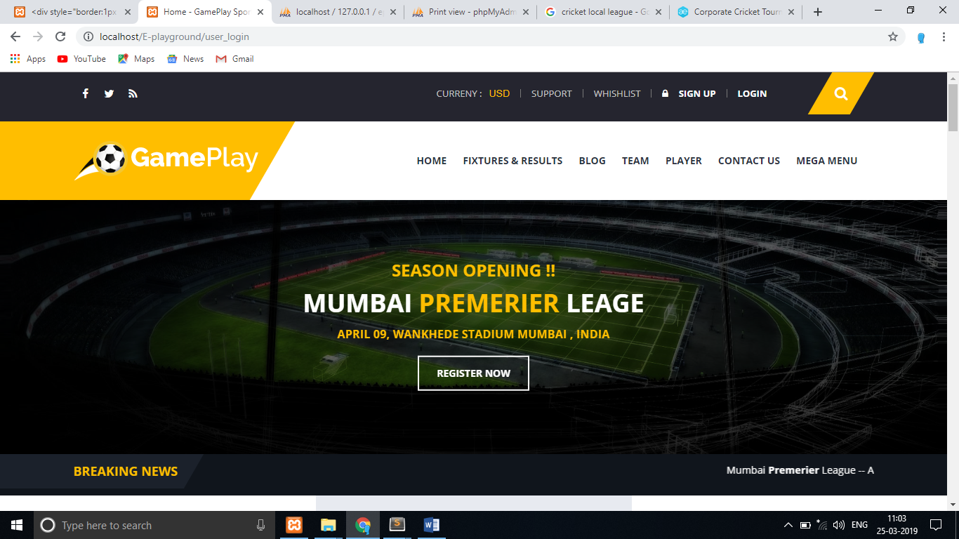

**Fig-1.** Main page of website through you can access all the content of your website. Suppose you are a player so you can go player dashboard by login. Otherwise you are service provider you can also go service provider dashboard.

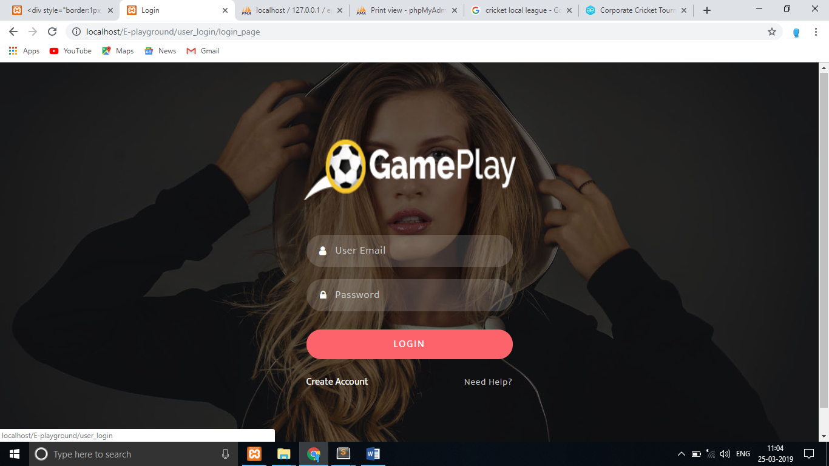

**Fig.**Login page of our website through this page user are go in their system.

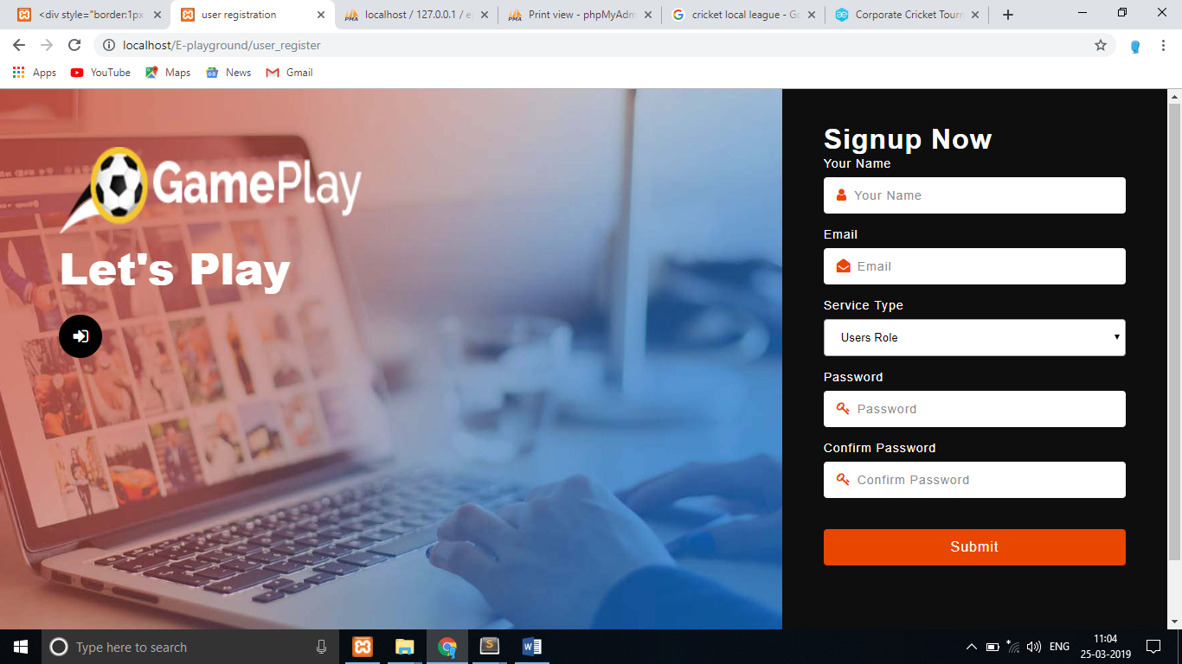

**Fig.** Registration Page through this all users register in the system.

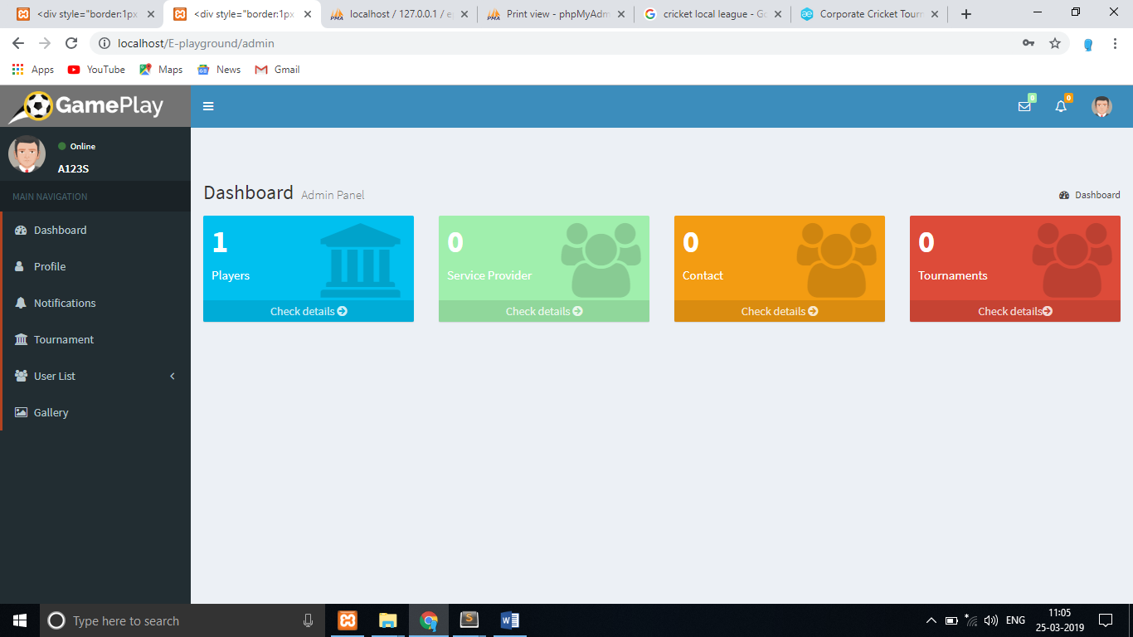

**Fig.** Admin dashboard here admin can all the content like then can check all the user list , tournament & as well their profile

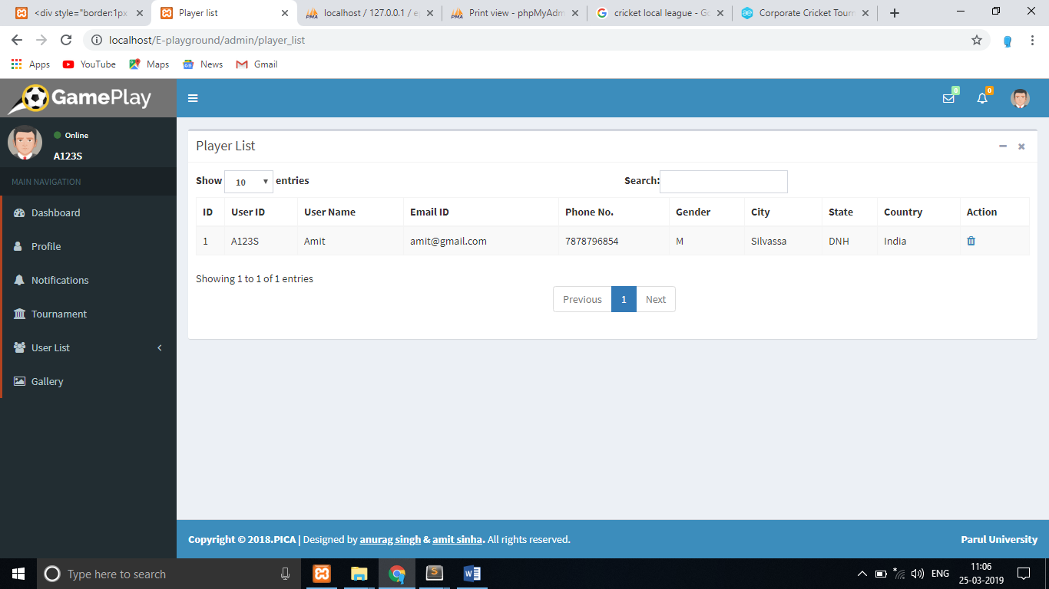

**Fig.**Player List here admin can allcheck all the player and the have rights to delete the player if they will be provided.

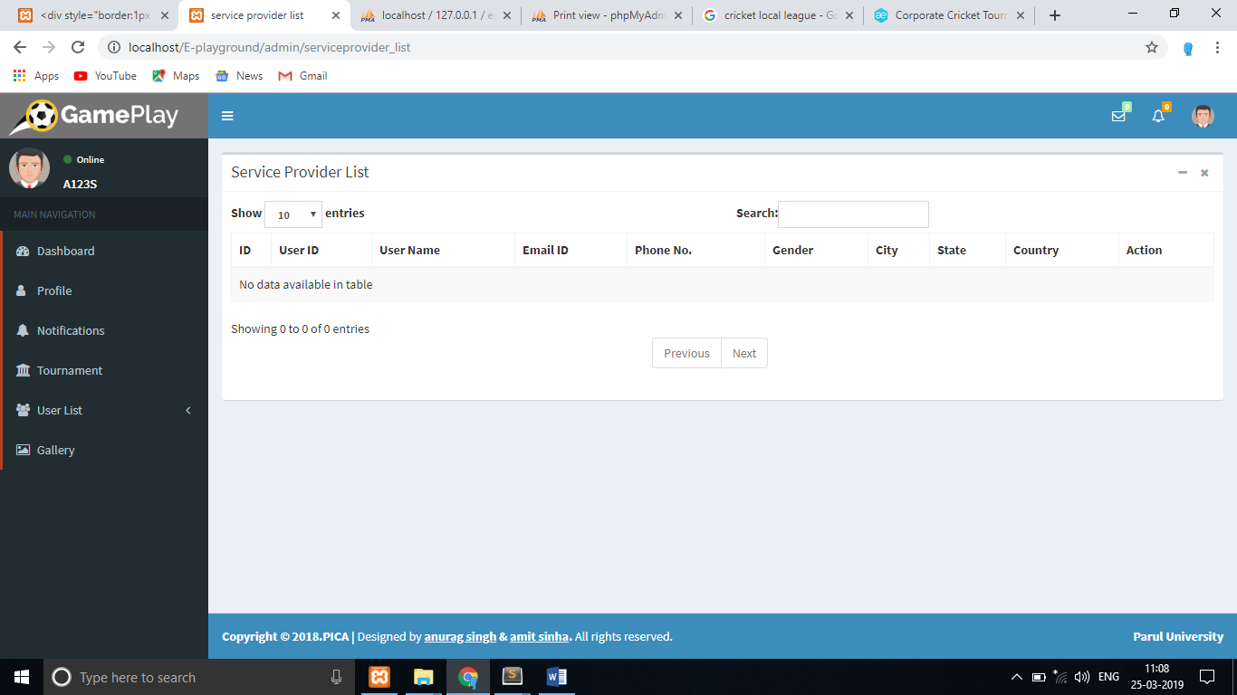

**Fig.**Serviceprovider List here admin can all check all the serviceprovider and the have rights to delete the player if they will be provided.

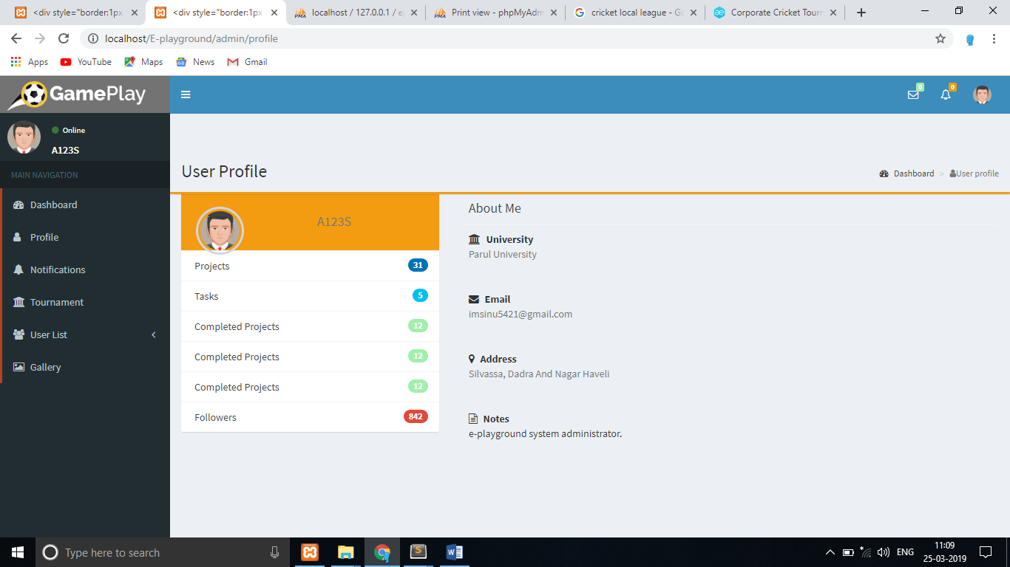

**Fig.**Admin Profile here admin can check their profile.

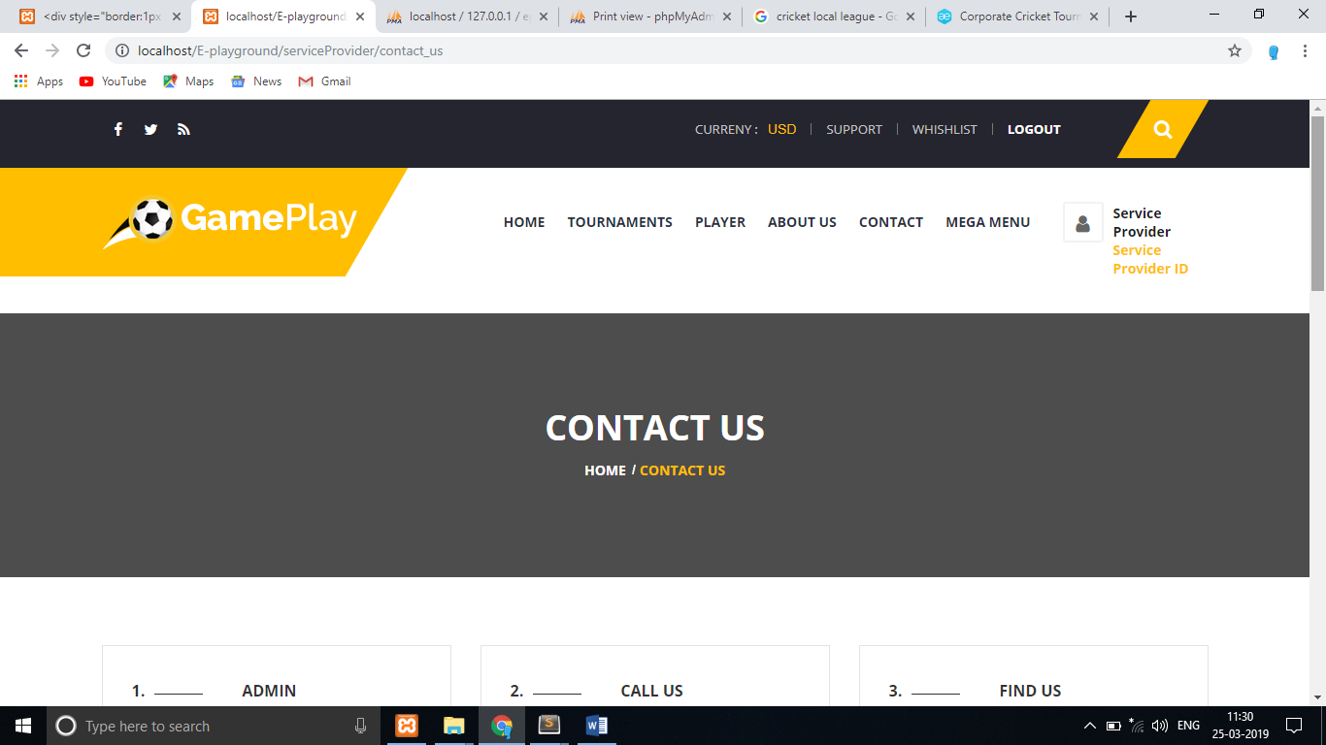

**Fig.**Service ProviderContact Us Page.

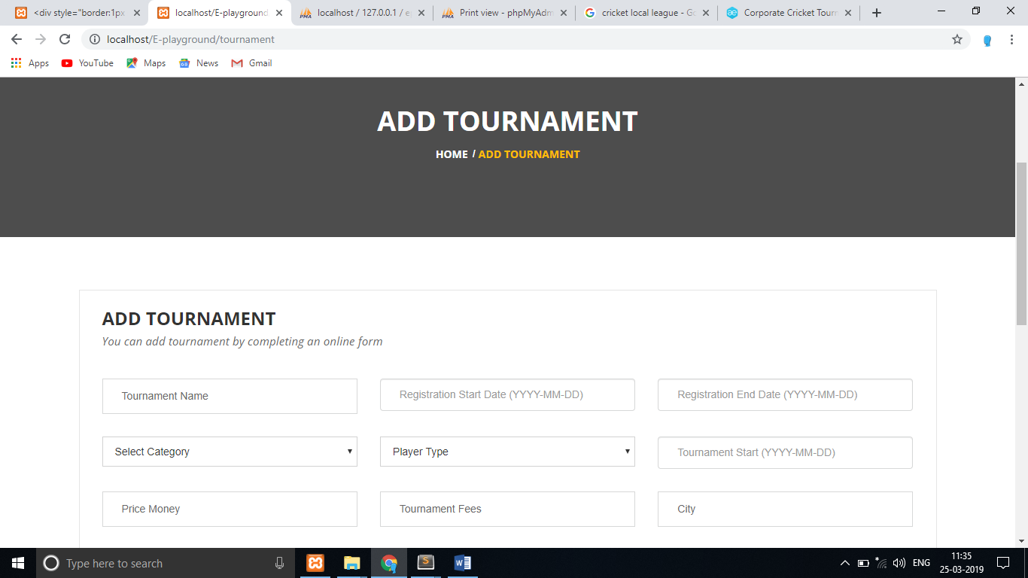

**Fig.**  Here Service Provider Can Add Tournament by felling the form through player can register easily.